**Y tidak distandardize**

# ANN

## Ekspor nilai

### All

Gen: [71.1782, 85.4585, -9.8003, -6.2432, 4.5590, 0.3827, 0.8445]

{'hidden': [71, 85],

'activation': 'leaky_relu',

'learning_rate': 0.3827,

'momentum': 0.8445}

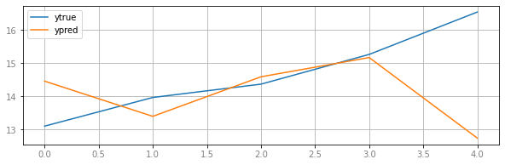

RMSE: 1.8274365830176382

MAPE: 7.922933439664946

MAE: 1.2095944409841521

Korelasi: -0.4128461372876119

### All kurs

{'hidden': [34, 92],

'activation': 'leaky_relu',

'learning_rate': 0.5361,

'momentum': 0.2337}

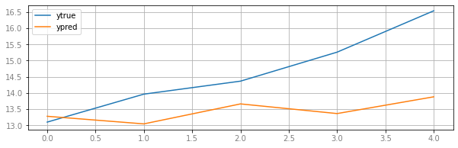

RMSE: 1.5530379883740297

MAPE: 8.279432870316631

MAE: 1.272681987719497

Korelasi: 0.7207521273319565

### All bi rate

{'hidden': [97, 94],

'activation': 'leaky_relu',

'learning_rate': 0.5561,

'momentum': 0.3453}

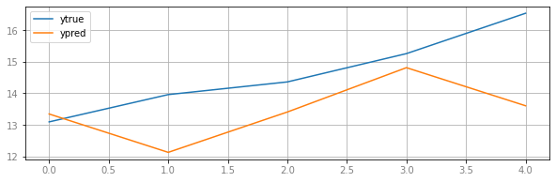RMSE: 1.6197026432882662

MAPE: 8.461163340407484

MAE: 1.2822327653251016

Korelasi: 0.4408758361984909

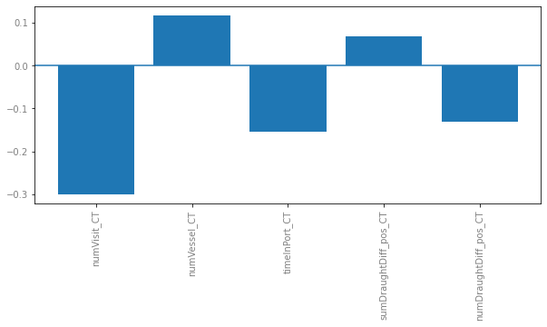

### Selec ()

{'hidden': [36],

'activation': 'leaky_relu',

'learning_rate': 0.8104,

'momentum': 0.7061}

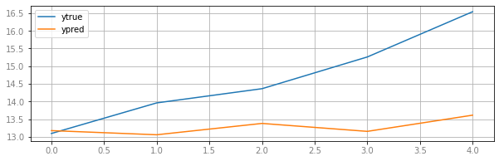

RMSE: 1.7183288778275194

MAPE: 9.076275780307927

MAE: 1.3985105419379447

Korelasi: 0.7196670251151727

### Selec () kurs

{'hidden': [18, 12, 84],

'activation': 'relu',

'learning_rate': 0.9335,

'momentum': 0.9793}

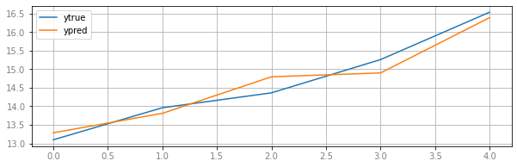

RMSE: 0.28180328223346984

MAPE: 1.756406639104783

MAE: 0.255835993253681

Korelasi: 0.9731054875493209

### Selec () bi rate

{'hidden': [36],

'activation': 'leaky_relu',

'learning_rate': 0.7643,

'momentum': 0.8073}

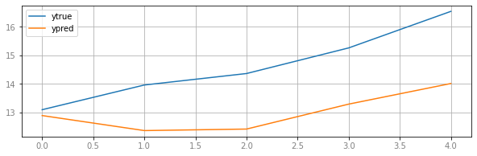

RMSE: 1.8229873478245657

MAPE: 10.938644837872937

MAE: 1.6474846564606385

Korelasi: 0.7980974914613209

### Reg (1 doang si)? Corr?

## Ekspor volume

### All

Gen: [27.3944, 86.6800, -9.7634, -6.4106, 1.6575, 0.0958, 0.6072]

{'hidden': [27, 87],

'activation': 'tanh',

'learning_rate': 0.0958,

'momentum': 0.6072}

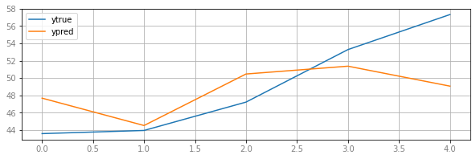

RMSE: 4.462328963470421

MAPE: 7.11539381556813

MAE: 3.617819061408747

Korelasi: 0.5863389101059332

### All kurs

{'hidden': [41, 70],

'activation': 'relu',

'learning_rate': 0.8988,

'momentum': 0.1789}

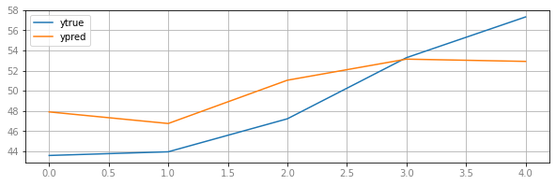 RMSE: 3.484279961180593

MAPE: 6.476218968016119

MAE: 3.102756102356794

Korelasi: 0.9051514959304922

### All bi rate

{'hidden': [87, 29, 78],

'activation': 'tanh',

'learning_rate': 0.4775,

'momentum': 0.3251}

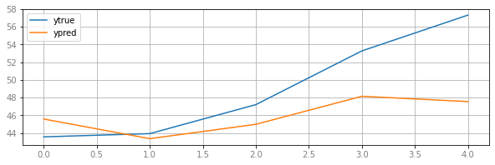

RMSE: 5.1153637614556535

MAPE: 7.451031280354902

MAE: 3.9369926888637226

Korelasi: 0.8418997267806057

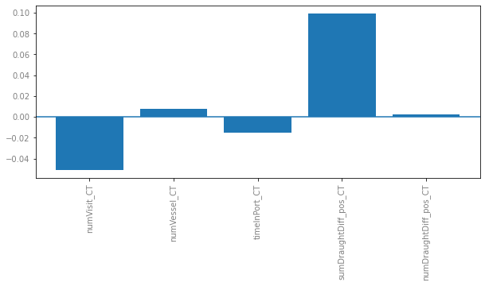

### Selec ()

{'hidden': [80, 73, 73],

'activation': 'relu',

'learning_rate': 0.1156,

'momentum': 0.6081}

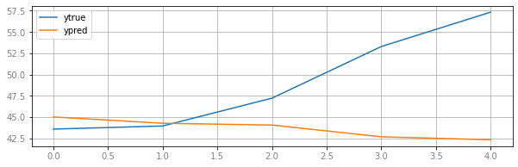

RMSE: 8.363743522122462

MAPE: 11.356909562641556

MAE: 6.104346690636509

Korelasi: -0.969186236931946

### Selec () kurs

{'hidden': [71, 84, 79, 8],

'activation': 'leaky_relu',

'learning_rate': 0.8840,

'momentum': 0.4806}

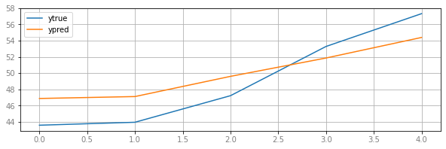 RMSE: 2.7263719222074383

MAPE: 5.518371377532015

MAE: 2.6392900913845354

Korelasi: 0.9933148953300156

### Selec () bi rate

{'hidden': [62, 75],

'activation': 'tanh',

'learning_rate': 0.4913,

'momentum': 0.0381}

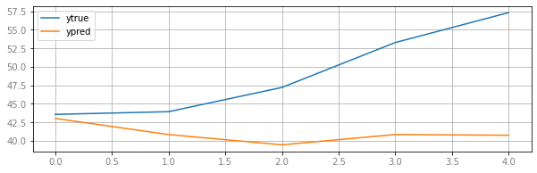

RMSE: 9.985625185694847

MAPE: 15.381008279462147

MAE: 8.074243282404643

Korelasi: -0.3281318530841251

## Impor nilai

### All

Gen: [59.9736, 50.7993, 78.3946, -6.9731, 4.0404, 0.8858, 0.7901]

{'hidden': [60, 51, 78],

'activation': 'leaky_relu',

'learning_rate': 0.8858,

'momentum': 0.7901}

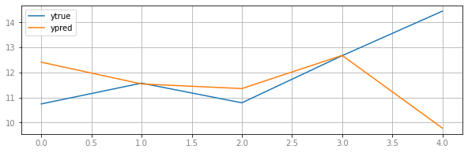

RMSE: 2.066509196144162

MAPE: 10.116207482338337

MAE: 1.3194940983370214

Korelasi: -0.4801238228464031

### All kurs

{'hidden': [81, 21, 91],

'activation': 'relu',

'learning_rate': 0.9227,

'momentum': 0.7907}

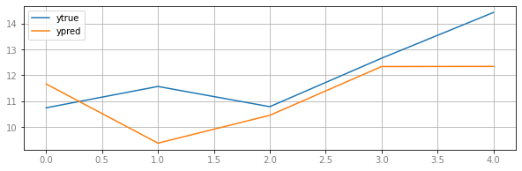

RMSE: 1.4329386800593262

MAPE: 9.543774231636345

MAE: 1.1737157261339917

Korelasi: 0.5788974731945188

### All bi rate

{'hidden': [95, 51],

'activation': 'identity',

'learning_rate': 0.9534,

'momentum': 0.7846}

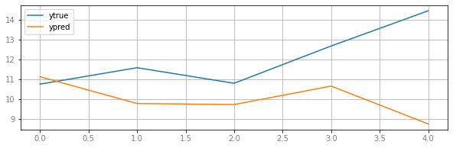

RMSE: 2.86784457505273

MAPE: 16.89032176243341

MAE: 2.194290458506417

Korelasi: -0.6311865123481722

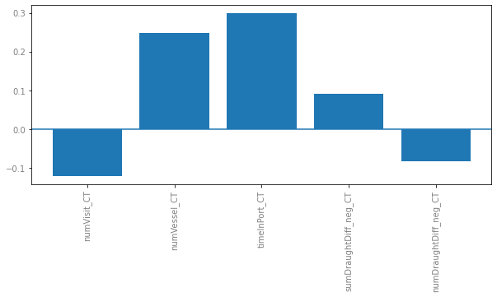

### Selec()

{'hidden': [52, 61],

'activation': 'relu',

'learning_rate': 0.8127,

'momentum': 0.9249}

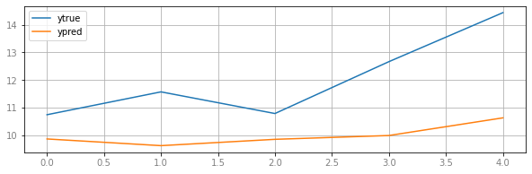

RMSE: 2.3282875731259036

MAPE: 16.23533370355384

MAE: 2.048908543157186

Korelasi: 0.8655385486692915

### Selec() kurs

{'hidden': [18, 24, 46, 99],

'activation': 'leaky_relu',

'learning_rate': 0.6880,

'momentum': 0.6440}

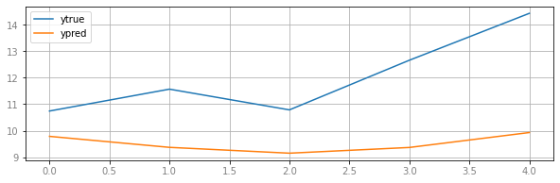

RMSE: 2.817151676736223

MAPE: 20.08730511068963

MAE: 2.5217492148412513

Korelasi: 0.5345357448941749

### Selec() bi rate

{'hidden': [99, 60, 97],

'activation': 'identity',

'learning_rate': 0.8610,

'momentum': 0.6640}

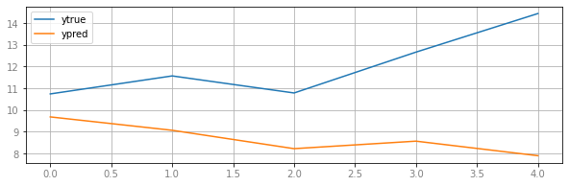

RMSE: 3.832149665904881

MAPE: 26.560789349523283

MAE: 3.350062990615809

Korelasi: -0.6524307131260987

## Impor volume

### All

Gen: [75.2281, 77.5254, -5.7552, -6.1370, 3.4016, 0.2238, 0.3668]

{'hidden': [75, 78],

'activation': 'relu',

'learning_rate': 0.2238,

'momentum': 0.3668}

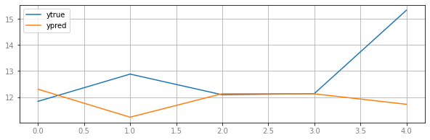

RMSE: 1.7847450877828637

MAPE: 8.131283826229337

MAE: 1.1537788096816706

Korelasi: -0.4833952680724504

### All kurs

{'hidden': [23, 27, 38, 57],

'activation': 'leaky_relu',

'learning_rate': 0.7229,

'momentum': 0.9701}

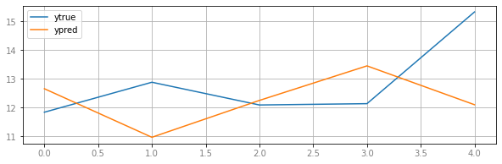

RMSE: 1.8184580969113233

MAPE: 11.00235050890535

MAE: 1.4879246210518875

Korelasi: -0.3239409672003862

### All bi rate

{'hidden': [3, 44, 50],

'activation': 'relu',

'learning_rate': 0.5780,

'momentum': 0.7875}

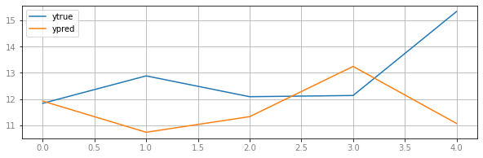

RMSE: 2.214669067748038

MAPE: 12.104050720307669

MAE: 1.6702630691428566

Korelasi: -0.4653624925088773

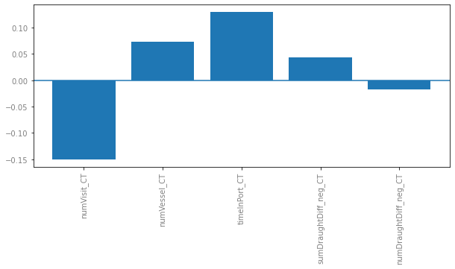

### Selec()

{'hidden': [43, 50],

'activation': 'relu',

'learning_rate': 0.9683,

'momentum': 0.9704}

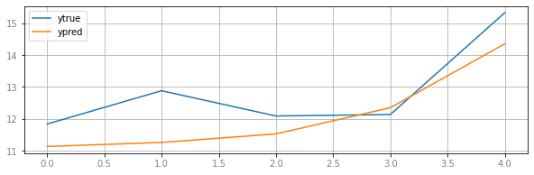

RMSE: 0.9425125182460822

MAPE: 6.263605986054069

MAE: 0.8156392785308825

Korelasi: 0.8870692366572591

### Selec() kurs

{'hidden': [66, 1, 98],

'activation': 'leaky_relu',

'learning_rate': 0.5692,

'momentum': 0.7773}

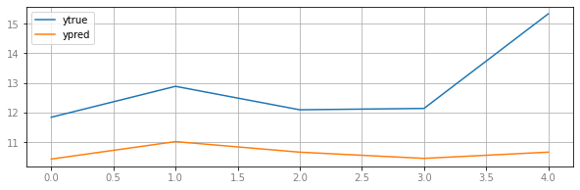

RMSE: 2.536846760039105

MAPE: 16.521192433289357

MAE: 2.2132032830784505

Korelasi: 0.29279381223408474

### Selec() bi rate

{'hidden': [66, 1, 98],

'activation': 'leaky_relu',

'learning_rate': 0.5692,

'momentum': 0.7773}

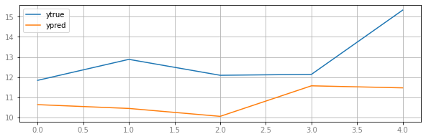

RMSE: 2.3170394266231056

MAPE: 15.18677821134508

MAE: 2.0248952468873513

Korelasi: 0.48222019201372934

ARIMA

# ARIMA

## Ekspor Nilai

### Self

(0,1)

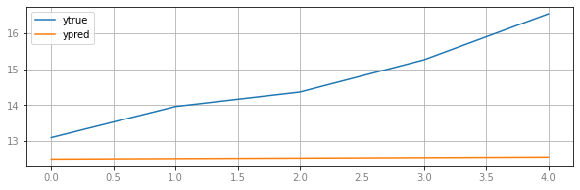

RMSE: 2.4116058238933697

MAPE: 13.92223506280374

MAE: 2.116452242226738

Korelasi: 0.9845579602685219

### All

(8,0)

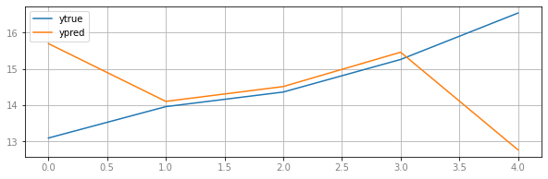

RMSE: 2.051406944954274

MAPE: 9.206708383757888

MAE: 1.3726747139446869

Korelasi: -0.6929466508390979

### All kurs

(8,0)

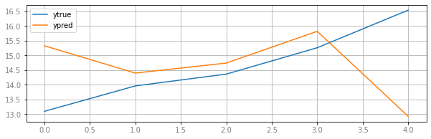

RMSE: 2.153806183704615

MAPE: 9.045566393029942

MAE: 1.3815651857028226

Korelasi: -0.6506804772173472

### All bi rate

(1,0)

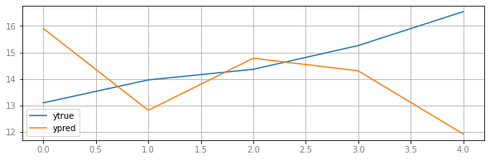

RMSE: 2.514032078053247

MAPE: 13.346842429435785

MAE: 1.9887103823203003

Korelasi: -0.7333042727901258

### Selec()

(8,0)

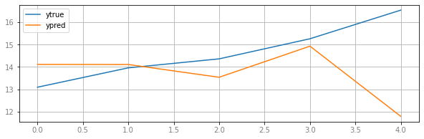

RMSE: 2.206692705629565

MAPE: 9.08473501076564

MAE: 1.4129216995319633

Korelasi: -0.6045518968833179

### Selec() kurs

(8,0)

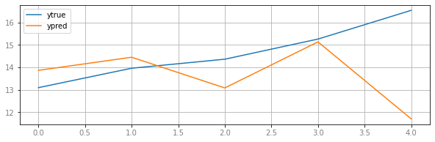

RMSE: 2.2732086682603425

MAPE: 9.6675348709623

MAE: 1.499411903558863

Korelasi: -0.502496506275493

### Selec() bi rate

(1,2)

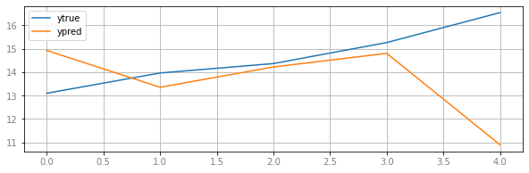RMSE: 2.6758054606862633

MAPE: 11.29406107482711

MAE: 1.737166986642786

Korelasi: -0.7403365274089813

## Ekspor Volume

### Self

(0,1)

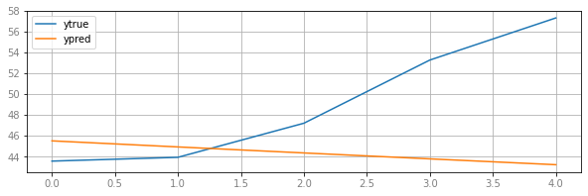

RMSE: 7.764340389721805

MAPE: 11.030990327502801

MAE: 5.87403022889674

Korelasi: -0.9629764640005223

### All

(0,1)

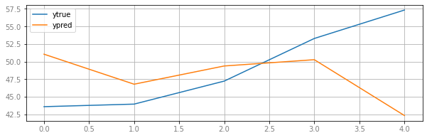

RMSE: 7.778861584966105

MAPE: 11.993219854909128

MAE: 6.093753978026035

Korelasi: -0.5894097437049363

### All kurs

(1,0)

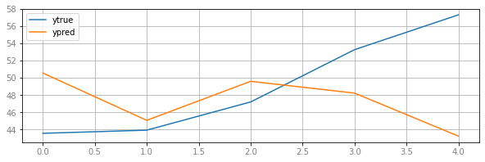

RMSE: 7.474744605520156

MAPE: 11.543429272429933

MAE: 5.927747013796532

Korelasi: -0.5404048744562201

### All bi rate

(0,2)

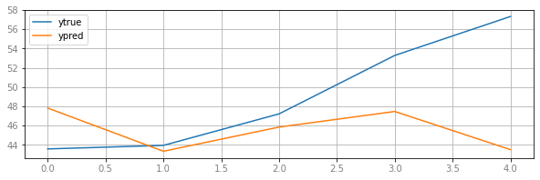

RMSE: 7.000556393506772

MAPE: 9.808483195910586

MAE: 5.171184524408959

Korelasi: -0.20465968081387031

### Selec()

(0,1)

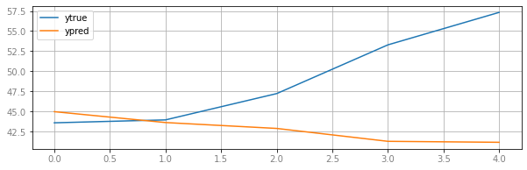

RMSE: 9.235784398584165

MAPE: 12.773602354092741

MAE: 6.846804382166392

Korelasi: -0.9306625979224771

### Selec() kurs

(1,0)

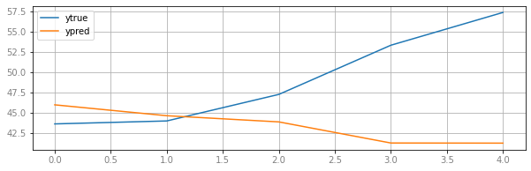

RMSE: 9.193201047332684

MAPE: 12.9582258823084

MAE: 6.9124462160905775

Korelasi: -0.9504589918667938

### Selec() bi rate

(0,0)

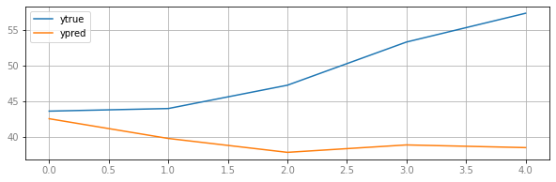

RMSE: 11.595713859050925

MAPE: 18.397969870650506

MAE: 9.600892639328961

Korelasi: -0.5853287072207358

## Impor Nilai

### Self

(2,0)

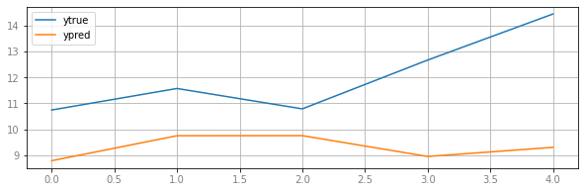

RMSE: 3.108664663953975

MAPE: 21.66403663276392

MAE: 2.7296031361803172

Korelasi: -0.11884144243136975

### All

(10,0)

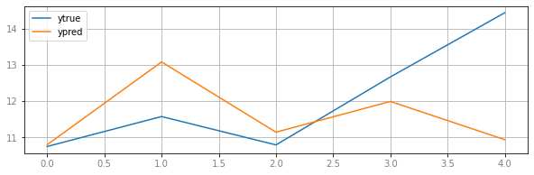

RMSE: 1.7413710789723404

MAPE: 9.279583827757904

MAE: 1.2188351983483972

Korelasi: -0.0724124568479326

### All kurs

(10,0)

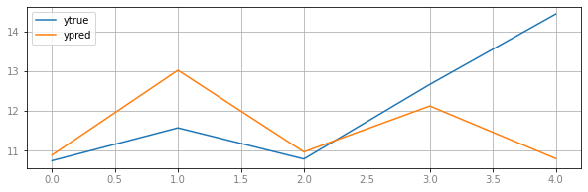

RMSE: 1.7728498271311381

MAPE: 9.003825695356493

MAE: 1.1910811778764718

Korelasi: -0.08923651842695145

### All bi rate

(10,0)

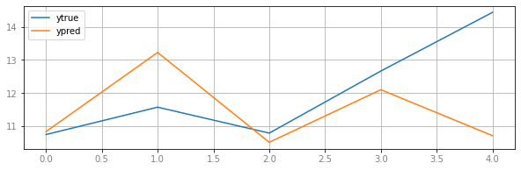

RMSE: 1.8471403855192934

MAPE: 9.605023356079396

MAE: 1.2638588423510726

Korelasi: -0.030980476504144448

### Selec()

Selec none sig :(

(0,1)

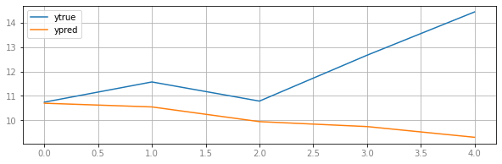

RMSE: 2.7078593426969957

MAPE: 15.137213172957159

MAE: 1.9930020628681249

Korelasi: -0.8176944621145444

### Selec() kurs

(10,0)

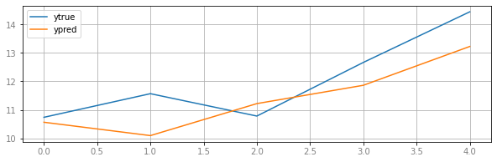

RMSE: 0.9479605966307013

MAPE: 6.616372797183169

MAE: 0.8185878486927987

Korelasi: 0.8691420573517586

### Selec() bi rate

(10,0)

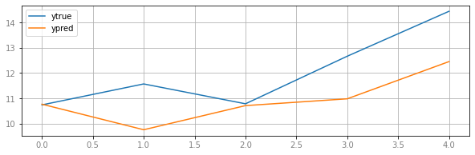

RMSE: 1.417835966952796

MAPE: 8.718178535121204

MAE: 1.1152120211020804

Korelasi: 0.7836947327035118

## Impor volume

### Self

(2,0)



RMSE: 3.108664663953975

MAPE: 21.66403663276392

MAE: 2.7296031361803172

Korelasi: -0.11884144243136975

### All

(10,0)



RMSE: 1.7413710789723404

MAPE: 9.279583827757904

MAE: 1.2188351983483972

Korelasi: -0.0724124568479326

### All kurs

(10,0)



RMSE: 1.7728498271311381

MAPE: 9.003825695356493

MAE: 1.1910811778764718

Korelasi: -0.08923651842695145

### All bi rate

(10,0)



RMSE: 1.8471403855192934

MAPE: 9.605023356079396

MAE: 1.2638588423510726

Korelasi: -0.030980476504144448

### Selec()

Selec none sig :(

(0,1)

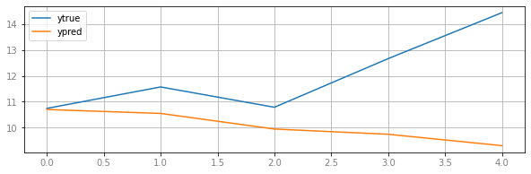

RMSE: 2.7077031611821023

MAPE: 15.135164559512887

MAE: 1.99276052842172

Korelasi: -0.8176710160080324

### Selec() kurs

(10,0)



RMSE: 0.9479605966307013

MAPE: 6.616372797183169

MAE: 0.8185878486927987

Korelasi: 0.8691420573517586

### Selec() bi rate

(10,0)



RMSE: 1.417835966952796

MAPE: 8.718178535121204

MAE: 1.1152120211020804

Korelasi: 0.7836947327035118